Design and Implementation of Smart Hospital using IoT
Alternate title: Smart System for Patient Monitoring
Objective:
The aim of this system is to monitor the patient’s health and early discovery of disease helps the doctors to move on to further treatment of patient. This reduces the cost and time of the patient.
Abstract:
The smart system for patient monitoring provides multiple options which change the path of diagnosis of disease. The system which we introduced reduces the cost of health care and helps the doctors to diagnose faster to take immediate treatment to patients.
The modern medicine nowadays is hard and shows a data that there are many more patients than the doctors. The doctors cannot be able to attend the emergencies every time so the smart system for patient monitoring can helps the doctors to diagnose earlier and we can reduce the burden of the doctors. Real time patient monitoring system helps the doctors to prioritize and treat the patients in emergency conditions.
Our system consists of heart&SPO2 sensor, LM35, node MCU, 16X2 LCD. Here the sensors and 16X2 LCD is interfaced with node MCU when there is a abnormal change in threshold value it immediately sends the warning notification to the doctor with the sensor values now the diagnosis is done by the doctor and prescribe medicine or any emergency he notifies the patient to admit in the hospital through node MCU.

Existing System:
In existing system of design and implementation of smart hospital using IOT consist of the wireless sensor network tracks patient health parameters and communicates via the GPRS interface to the far end. Where the doctor can constantly watch the sick patients illness on his Smart phone.
Proposed System:
In our proposed work patients health data is send to doctor through node MCU and doctor prescribes the medicine or incase any emergency the doctor notifies the patient by admit in hospital and refers hospital to patients using database.
Block Diagram:
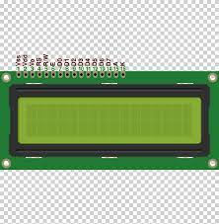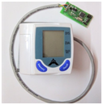
Cloud database
LM35
16X2 LCD
Node MCU
Node MCU
Doctor’s computer
BP Sensor

Hardware Requirements:
- BP Sensor
- LM35
- Node MCU-2
- 16X2 LCD
Software Requirements:
- Arduino IDE

